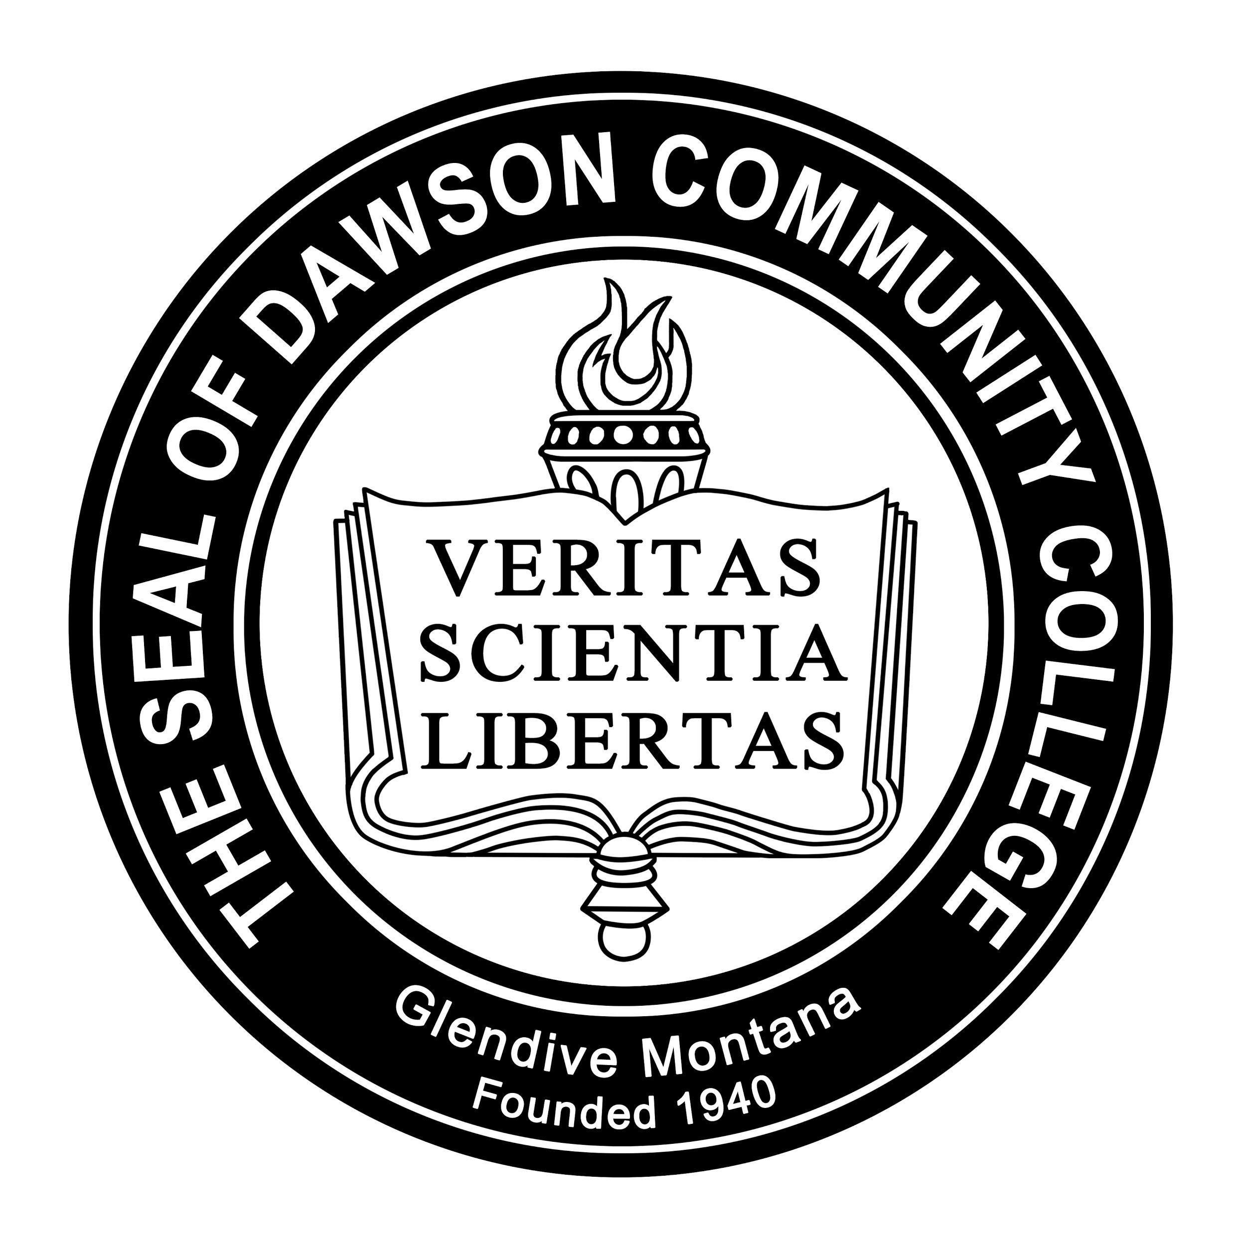
BIENNIAL REVIEW OF DAWSON COMMUNITY COLLEGE’S DRUG AND ALCOHOL ABUSE PREVENTION PROGRAMMING REVIEW TIME FRAME: CALENDAR YEARS 2018; 2019

[12/31/2020]
Dawson Community College
300 College Dr. Glendive, MT 59330

Introduction
Dawson Community College (the College, the institution, DCC) is deeply committed to supporting the safety and health of its students and employees in furtherance of its mission. The institution is dedicated to identifying and addressing community and area needs, and providing opportunities for lifelong learning. DCC is also committed to providing accessible, affordable quality education and training. As part of that commitment, the College has implemented comprehensive alcohol and drug abuse prevention programming. This programming incorporates a series of strategies including policies/procedures, formal notifications, education, cross-campus collaboration, social opportunities, academic involvement, interventions, enforcement, analysis, and services.
The College monitors the effectiveness of this programming. This report is the result of a biennial review of Dawson ’s alcohol and drug prevention programming, in compliance with Federal Drug Free Schools and Campuses Regulations (34 C.F.R. Part 86).
Biennial Review Process
In support of the safety and health of its students and employees, and pursuant to its obligation to conduct a biennial review of its drug and alcohol abuse prevention programs, Dawson has conducted an administrative review of those programs that are required to be reviewed every other year. The purpose of this review is (1) to consider whether the College is meeting its obligations under the Federal Drug Free Schools and Campuses Regulations and (2) to summarize the programs, as well as related policies and procedures, and to recommend any appropriate enhancements to those programs, policies and procedures.
Dawson has formed a Task Force to conduct the 2018/2019 biennial review. Associate Dean of Student Success and the Director of Financial Aid serve as co-chairs of that Task Force. Other members include:
- Athletic Director
- Director of Housing
- Human Resources
- Admission Specialist
The following materials and programs were examined as part of this biennial review:
The Higher Education Amendments of 1998, (P.L. 105-244) and the Drug-Free Schools and
Communities Act Amendments of 1989, (P.L. 101-226)
U.S. Department of Education, Complying with the Drug-Free Schools and Campuses
Regulations, http://www.higheredcompliance.org/resources/resources/dfscr-hec-2006-manual.pdf
National Institute on Alcohol Abuse and Alcoholism, College Drinking – Changing the Culture,
http://www.collegedrinkingprevention.gov/
• Dawson Community College Student Handbook
• Dawson Community College Annual Campus Security and Fire Safety Report
• Dawson Community College Drug and Alcohol Abuse Prevention Information
• Dawson Community College Drug Free Workplace Policy
• Dawson Community College Student Conduct Code Alcohol/Drug Violations
• Dawson Community College Student Conduct Code Regulations
• Dawson Community College Tobacco Usage Policy
• Alcohol and Drug Policy documents available to all faculty, students and staff
• Housing and Residence Life Application/Agreement
• Housing and Residence Life Residence Life Manual
• Housing and Residence Life Alcohol, Drug, and Tobacco conduct cases reviewed

Annual Notification Process
Dawson Community College has developed a notice that is sent to students and employees covering the following:
- Standards of conduct prohibiting unlawful possession, use or distribution of illicit drugs and alcohol on the institution’s property or as part of its activities
- A description of the health and safety risks associated with the use of illicit drugs and abuse of alcohol
- A description of applicable legal sanctions under local, state and federal law
- A description of counseling or treatment programs
- A clear statement and description of the disciplinary sanctions the institution will impose on students and employees.
In addition, a specific procedure is being developed to ensure this notice is provided in writing to students and employees annually, to students at various times throughout the year, and to employees at the time of hire and in new employee information packets including scheduled monthly emails being sent out.
Dawson Community College’s process for distributing the notice meets the requirements of the Drug-Free Schools and Campus Regulations.
This report is emailed to every student, faculty, and staff member associated with DCC. Each student, faculty, and staff member is issued a specific email address when enrolled or employed at DCC. These addresses are maintained by DCC Information Technology. Therefore, DCC believes this e-mail process to be the most efficient way of reaching all parties. This report is also maintained on the DCC web page. A hard copy of this report is also maintained in the Financial Aid Office . Anyone wishing to receive a copy of this report may request a copy through the Vice President of Academic and Student Affairs.

Policy Inventory
Dawson Community College Policy BP 2-8: Alcohol Drugs and Tobacco
Dawson Community College Policy CP 2-8: Drug-Free Workplace
Dawson Community College Policy BP 3-2: Alcohol Drugs and Tobacco
Dawson Community College Policy CP 3-2: Alcohol and Dangerous Drugs
Student Handbook
Student Conduct Code
Residence Life Manual
Employee Handbook

Programs
Dawson Community College wants to ensure that all of our students, faculty, and staff have a rich and worthwhile educational experience in a safe community environment. In order to maintain such an environment, the institution’s goal is to set clear policies that endorse an alcohol and drug abuse free environment to our campus community. Dawson Community College will provide ongoing educational support and resources on alcohol and drug abuse for our institutional community.
Dawson Community College goals include the development of a strategic plan on alcohol and drug abuse tracking, utilizing social media to inform the campus community of health risks, and drug and alcohol awareness events to promote safety to our campus community.
Dawson includes several evidence-based strategies designed to limit alcohol and drug abuse in its community and activities. These include the following:
- AlcoholEdu - An interactive online program hosted by EverFi designed to reduce the negative consequences of alcohol amongst students. This program is for all incoming freshmen and is the responsibility of Student Affairs.
- Proud participant of the Healthy College Montana staffed by The Health, Safety, & Well-being Initiatives of NASPA to reduce tobacco and chronic disease prevention areas of concern on Montana college campuses working towards making our campuses a safer space for students to live, work, learn, and grow.
- All Student Life activities throughout the academic year are alcohol and drug free options.
Enforcement
Enforcement of the College’s policies and procedures concerning alcohol and drug use rests largely with Student Services and Human Resources. Dawson’s enforcement process for students includes the Dean of Student Success gathering reports of conduct violations made by College personnel. The Director of Human Resources is responsible for employee conduct violations related to alcohol and drugs. The table below in section “Enforcement Consistency Analysis” summarizes sanctions imposed for student incidents involving alcohol and drugs that were reported to campus officials, and alcohol- and drug-related fatalities, that have occurred on campus or as part of Dawson’s activities. All of the incidents in the chart occurred in the College’s residential facilities. These incidents were reported as student discipline matters. There were no employee conduct violations related to alcohol and drugs during the review period covered by this report.

Enforcement Consistency Analysis
The Team has assessed the consistency of imposed sanctions for violations of disciplinary standards and codes of conduct and finds disciplinary actions to be consistent with each circumstance of policy violation.
The handling of the situations shows consistency by the College, regardless of the offending students’ race, ethnicity, gender, or other protected category or the offending students’ involvement in any particular student activity or athletic program.
The table below summarizes sanctions imposed for student incidents involving alcohol and drugs that were reported to campus officials. These violations occurred throughout all Dawson Community College campus locations. Violations submitted to campus officials that result in an arrest or citation are counted once in the Arrest and Citations and not double counted also in the Alcohol Violations Submitted to Campus Officials.
 | Calendar Year 2018 | Calendar Year 2019
Alcohol Violations Submitted to Campus Officials -Students | 2 | 3
Arrests and Citations based on Alcohol Violations- Students | 19 | 3
Total Alcohol Violations -Students | 21 | 6
Drug Violations Submitted to Campus Officials - Students | 3 | 2
Arrests and Citations based on Drug Violations- Students | 0 | 2
Total Drug Violations -Students | 3 | 4

The table below summarizes sanctions imposed for employee incidents involving alcohol and drugs that were reported to campus officials. These violations occurred throughout all Dawson Community College campus locations. Violations submitted to campus officials that result in an arrest or citation are counted once in the Arrest and Citations and not double counted also in the Alcohol Violations Submitted to Campus Officials.

 | Calendar Year 2018 | Calendar Year 2019
Alcohol Violations Submitted to Campus Officials - Employees | 0 | 0
Arrests and Citations based on Alcohol Violations -Employees | 0 | 0
Total Alcohol Violations -Employees | 0 | 0
Drug Violations Submitted to Campus Officials - Employees | 0 | 0
Arrests and Citations based on Drug Violations - Employees | 0 | 0
Total Drug Violations - Employees | 0 | 0

Assessment
The Team has considered the overall effectiveness of Dawson’s alcohol and drug abuse prevention programming. The Team believes that, in light of the College’s position as a local community college and its available resources and personnel, overall the College’s drug and alcohol abuse prevention program is effective.
During the course of its review, the team identified the following strengths/positives with the College’s drug and alcohol abuse prevention program during the two year review period:
- DCC provided consistent sanctioning when enforcing drug and alcohol policies.
- Where there are conduct issues related to drug and alcohol abuse, the Team found that they are limited to students residing in the College’s student housing.
- An annual notification document has been developed that aligns with legal requirements.
- A procedure has been developed to ensure a biennial review occurs every other year.
- A “Drug and Alcohol Abuse Prevention Program” webpage on the College’s website has been developed that houses the notification document and the most recent biennial review report. https://www.dawson.edu/current-students/student-success/student-handbook.html/title/health-information

The College’s drug and alcohol policies are simple and easy to understand – the Team is unaware of any situations in which members of the campus community have expressed confusion or misunderstanding of these policies.
Recommended Policy and Programming Revisions

At this time, the Team does not have any recommended policy revisions. Regarding programming efforts, the Team recommends the following items for further consideration:
- Increase targeted programming to students residing in the College’s residential facilities (due to the number of drug and alcohol related conduct violations from this population).
- Increase collaboration with faculty and staff on getting alcohol/drug messaging out to students.
- Development of a social media-driven drug and alcohol abuse prevention campaign (due to social media being such an important part of people’s lives, especially students).
- Find ways to publicize to students and employees that if they are having issues with substance abuse, College officials can help direct them to available resources.
- Recommend that the DCC 101 class cover alcohol and drug abuse. DCC 101 is a graduation requirement for all students seeking an associates degree. The responsibility lies with the Dean of Academics; though various faculty members may present this information.
- Incorporation of drug/alcohol messaging into other programming materials (e.g., include some discussion of alcohol and drugs in mandated sexual misconduct programming).
- A procedure has been identified to ensure this notification document is appropriately distributed to students and employees.

Reason for Procedure
Dawson is required to annually distribute in writing to students and employees a notification of certain standards related to the College’s drug and alcohol abuse prevention program (DAAPP). In addition, the College must conduct a biennial review of its DAAPP. The Introduction to the Clery-Related Internal Procedures document contains guidance that should be considered when implementing this procedure.

Annual Notification
The College maintains a web page titled “Health Information” As required by law, this document includes the following information as it relates to both students and employees:
- Standards of conduct that clearly prohibit the unlawful possession, use, or distribution of illicit drugs and alcohol by students and employees on Dawson ’s property or as part of any of the College’s activities;
- Clear statements that the school will impose sanctions for violations of standards of conduct and descriptions of sanctions;
- A description of applicable legal sanctions under state, local, and federal law;
- A description of health risks; and
- Descriptions of available counseling, treatment, rehabilitation, or re-entry programs.
This notification web page may be amended from time to time as deemed necessary by the biannual review team.
The current notification document is published on the College’s website. During the first two weeks of each academic year (Fall semester), the Vice President of Student Affairs office will ensure that students and employees are sent an email to their @Dawson.edu email accounts that includes the following statement (or a substantially similar statement) and a direct link to the document on the College’s website:
In accordance with federal law, Dawson Community College is providing you with information regarding its drug and alcohol abuse prevention program. The purpose of this information is to give you an overview of the College’s standards related to alcohol and drugs, discuss possible institutional sanctions and legal sanctions, and inform you of health risks and available resources. This information is available here: https://www.dawson.edu/current-students/student-success/student-handbook.html/title/health-information
If you have any questions about this information, please contact the Vice President of Student Affairs office at 406-377-9403
The Vice President of Student Affairs office will ensure the email above is sent to students according to the following schedule:
- The 1st of each month year round (in order to ensure that new employees and new students who enroll for 15 week, a 10-week and 6-week terms within the semester or during the Winter Session will also receive the notification);

The Vice President of Student Affairs office will also communicate with other College personnel to ensure that any students who enroll under unusual circumstances are also provided with the notification document. The Director of Human Resources will ensure that all new employees are provided with a copy of the notification document in their orientation materials.
Prior to notifications being made as described above, the College official making the notification will ensure that the correct contact information for the Director of Human Resources and The Vice President of Student Affairs office is included. In addition, prior to the email notifications being sent, the College official will ensure the link to the notification on the website is a direct link and is working properly.
Biennial Review
In every even-numbered year, Dawson will engage in a full review of its DAAPP to (1) determine its effectiveness and implement changes to the program if they are needed, and (2) ensure that disciplinary sanctions are consistently enforced.
During each even-numbered year, the review will take place sometime between June and December (as schedules of the Task Force members allow) and will cover the two immediately preceding academic years. For example, the 2020 review will cover academic years 2018-2019 and 2019-2020. Each review will culminate in a report that is published on the College’s website on or before December 31 of the year of review.

